Circular Queue

Circular Queue is a linear data structure in which the operations are performed based on FIFO (First In First Out) principle and the last position is connected back to the first position to make a circle. It is also called **‘Ring Buffer’**.

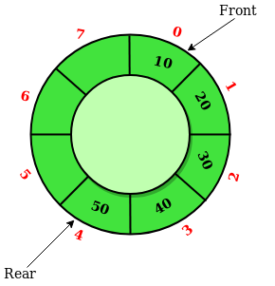

In a normal Queue, we can insert elements until queue becomes full. But once queue becomes full, we can not insert the next element even if there is a space in front of queue.

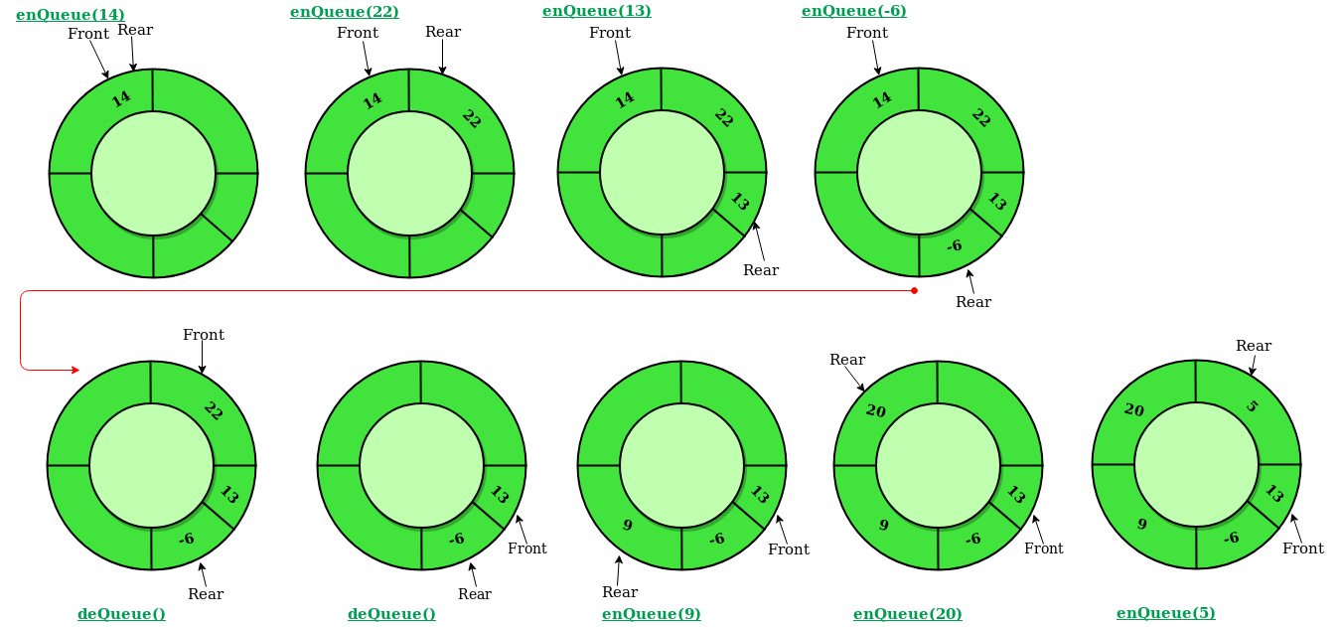

Operations on Circular Queue:

* **Front:** Get the front item from queue.
* **Rear:** Get the last item from queue.
* **enQueue(value)**This function is used to insert an element into the circular queue. In a circular queue, the new element is always inserted at Rear position.

**Steps:**

* 1. Check whether queue is Full – Check ((rear == SIZE-1 && front == 0) || (rear == front-1)).
  2. If it is full then display Queue is full. If queue is not full then, check if (rear == SIZE – 1 && front != 0) if it is true then set rear=0 and insert element.
* **deQueue()** This function is used to delete an element from the circular queue. In a circular queue, the element is always deleted from front position.

**Steps:**

* 1. Check whether queue is Empty means check (front==-1).
  2. If it is empty then display Queue is empty. If queue is not empty then step 3
  3. Check if (front==rear) if it is true then set front=rear= -1 else check if (front==size-1), if it is true then set front=0 and return the element.